Results when viewed in QTP 9.2
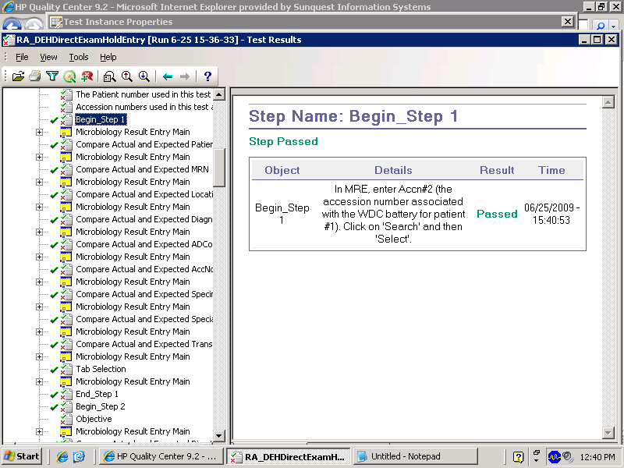

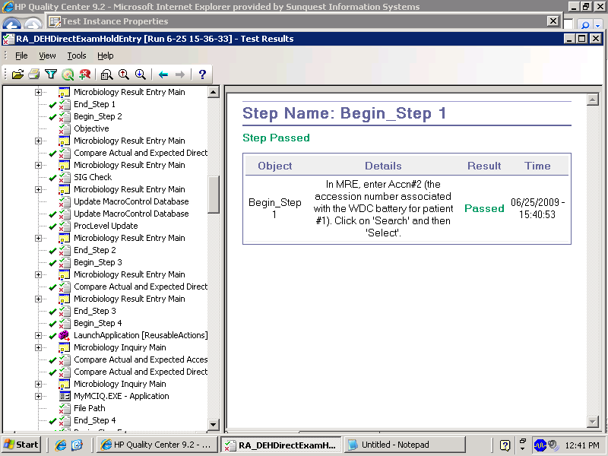

Results when viewed in QTP10.0

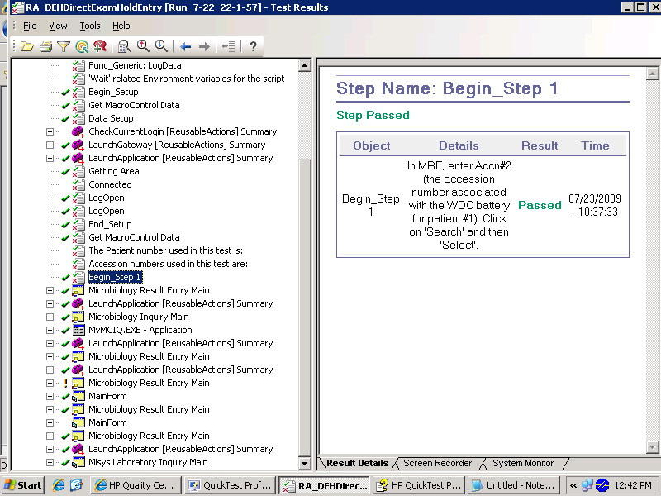
We need to expand this node to see End_step1, Begin_Step2 etc ……..



